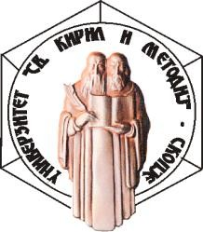 | Ss. CYRIL AND METHODIUS UNIVERSITY INSTITUTE OF MACEDONIAN LANGUAGE “KRSTE MISIRKOV” – SKOPJE  Address: 5 Grigor Prlichev Street, 1000 Skopje,  RN Macedonia  Center: +389 2 3114 733 phone/fax: +389 2 3222 225 E-mail address: kontakt@imj.ukim.edu.mk  Website: www.imj.ukim.edu.mk | 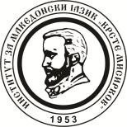

VI International Conference on Linguistics
“MACEDONIAN LANGUAGE – A SOURCE OF SCIENTIFIC RESEARCH”
(Skopje, October 20–21, 2021)

APPLICATION
Name and Surname
Title
Institution
Address
E-mail
Title of the paper
Abstract in Macedonian/in the language of the paper
(up to 250 words)
Keywords in Macedonian/in the language of the paper (up to 5)
Participation | In person | Online

